# More Soap UI Notes V2

## How to set Authorisation

From within the Request step, go to the Request Properties tab and enter values for the Username, Password and Domain fields (these fields will already exist and are likely to be specific to the request, so you may not have a Domain fields for example).

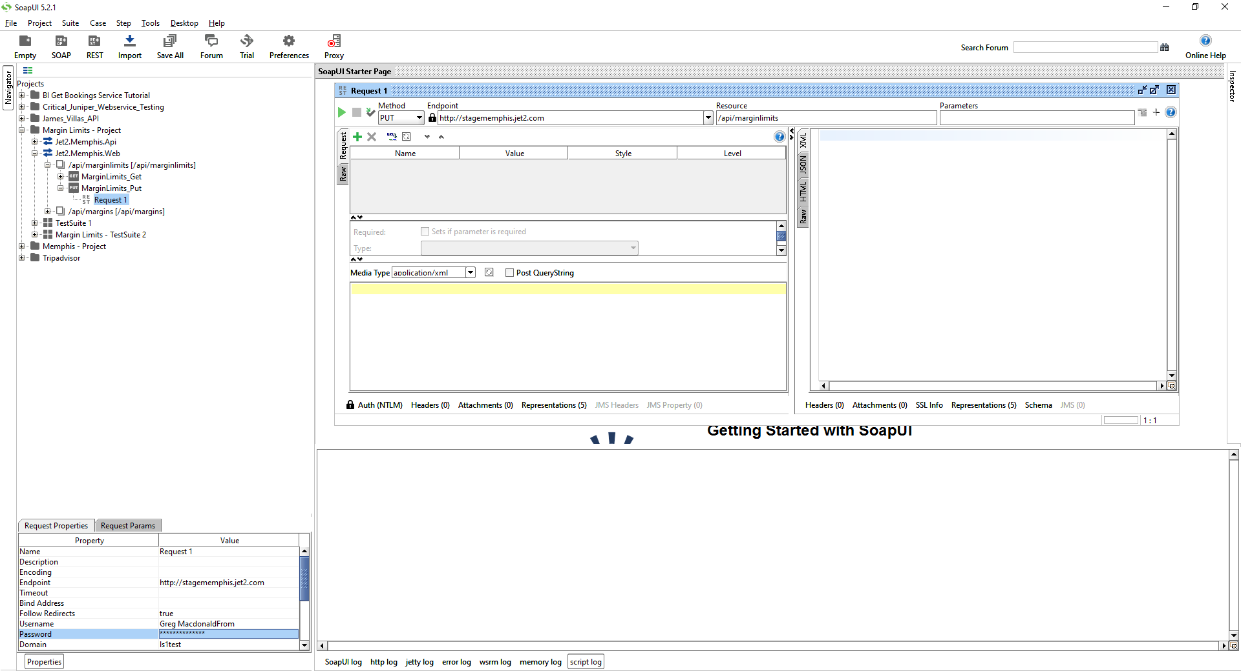

From within the Request step, Click on the Auth tab in the Request window. Select Add New Authorisation and select the appropriate type, click on OK then enter the required authorisation values.

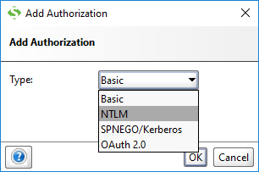

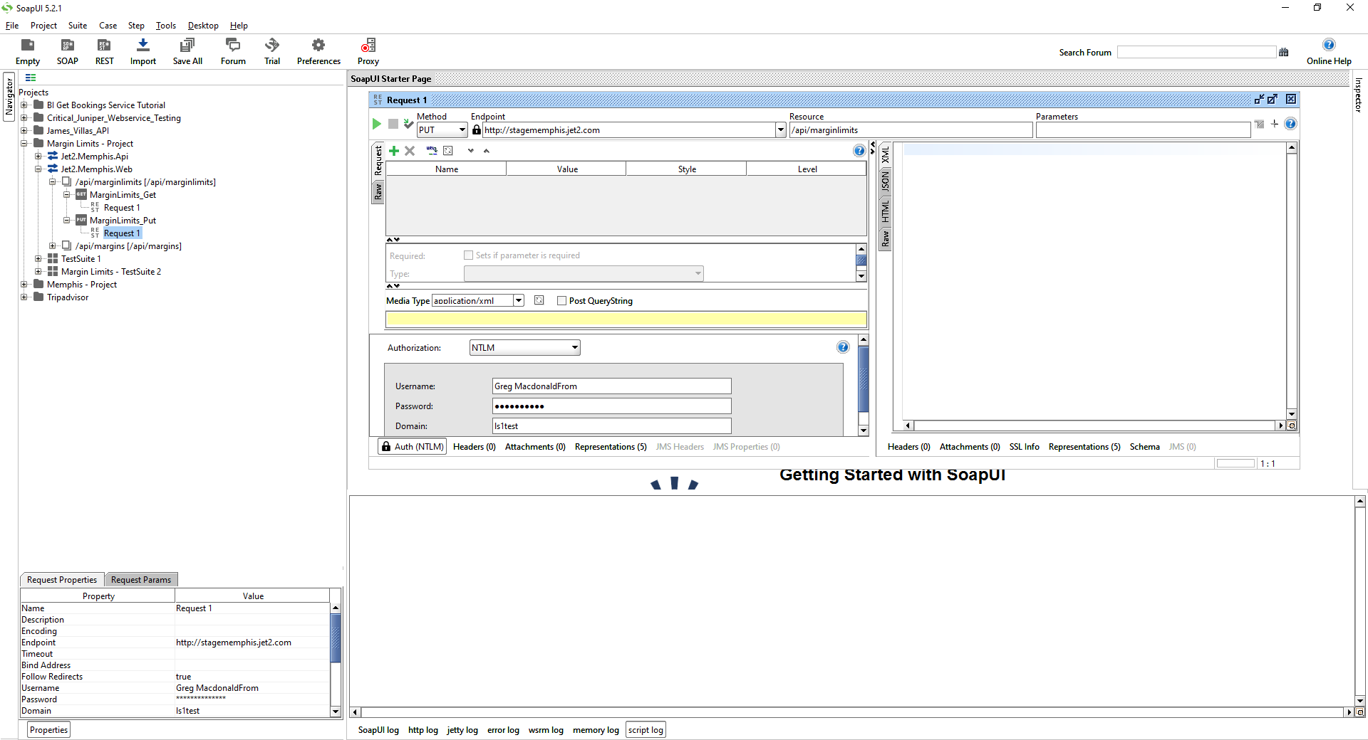

## Selenium – Using Context Injection to pass data to tests

See this link:

<https://github.com/techtalk/SpecFlow/wiki/Context-Injection>

##Examples

In the first example we define a POCO for holding the data of a person and use it in a *given* and a *then* step that are placed in different binding classes.

//THIS IS THE DEFINTION OF YOUR DATA, IT COULD BE AN BANK ACCOUNT FOR EXAMPLE

//I THINK THAT THIS CLASS WOULD DEFINED IN A SEPARATE C# FILE (PlainOldCObject) AND THEN IS //INCLUDED IN THE STEP DEFINITON CLASS VIA AN INCLUDES STATEMENT

public class PersonData // the POCO for sharing person data

{

public string FirstName;

public string LastName;

}

//THIS IS YOUR STEP DEFINITION

[Binding]

public class MyStepDefs

{

//THE STEP DEFINITION CLASS CONTAINS AN OBJECT OF THE SAME TYPE AS YOUR //DATA CLASS DEFINED ABOVE. IT HAS A CONSTRUCTOR THAT SETS THE DATA //OBJECT VALUES FROM THE GIVEN PARAMETER

private readonly PersonData personData;

public MyStepDefs(PersonData personData) // use it as ctor parameter

{

this.personData = personData;

}

//AN EXAMPLE OF A STEP DEFINTION METHOD THAT USES THE DATA OBJECT

[Given]

public void The_person_FIRSTNAME_LASTNAME(string firstName, string lastName)

{

personData.FirstName = firstName; // write into the shared data

personData.LastName = lastName;

//... do other things you need

}

}

//ANOTHER EXAMPLE OF A STEP DEFINTION CLASS AND ITS METHOD USING THE DATA OBJECT

[Binding]

public class OtherStepDefs // another binding class needing the person

{

private readonly PersonData personData;

public OtherStepDefs(PersonData personData) // ctor parameter here too

{

this.personData = personData;

}

[Then]

public void The_person_data_is_properly_displayed()

{

var displayedData = ... // get the displayed data from the app

// read from shared data, to perform assertions

Assert.AreEqual(personData.FirstName + " " + personData.LastName, displayedData, "Person name was not displayed properly");

}

}

## Other useful links

This might be of use for Extent reports

<http://blogs.perficient.com/delivery/blog/2017/01/20/driver-manager-for-selenium-web-driver-and-extent-reports/>

This might be useful for driver manager class

<http://overtest.me/webdrivermanager-fabric-example/>

<https://www.codeproject.com/Articles/1193172/WebDriverManager-fabric-example-for-Selenium-based>

<https://www.javatips.net/api/selenese-runner-java-master/src/main/java/jp/vmi/selenium/webdriver/WebDriverManager.java>